WEB SERVER W

What is Apache ?
Apache is a freeware & is the Most Popular
& widely used Web Server which consumes 60% of web
market that can be configured in both windows and LINUX.

How Web Server works ?

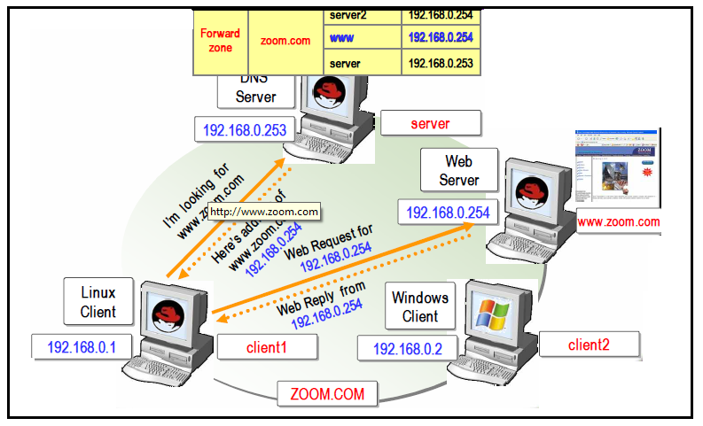

Requirements

Packages

httpd-2.0.52-9.ent.i386.rpm

httpd-devel-2.0.52-9.ent.i386.rpm

httpd-manual-2.0.52-9.ent.i386.rpm

httpd-suexec-2.0.52-9.ent.i386.rpm

Port Numbers

80 Http

Configuration File

/etc/httpd/conf/httpd.conf

Service

Httpd

Daemon

Httpd

Configuring HTTP Server

Install the package by using rpm installation method

[root@Server Packages]# cd /media/Fedora\ 13\ i386\ DVD/Packages/
[root@comp1 ~]# rpm -ivh httpd* --force –aid
OR
Install the package by using yum installation methods(Installation through Internet)

[root@comp1 ~]# yum install httpd*

Open configuration for editing

[root@comp1~]# vi etc/httpd/conf/httpd.conf

Change the below options

ServerAdmin root@IT.com

ServerName www.IT.com:80

DocumentRoot "/var/www/html"

DirectoryIndex zoom.html

Save by :wq
Note:- In Document Root path is /var/www/html/ where the html web pages are stored and the main html file name should be index.html
To restart the HTTP services

[root@comp1 ~]# service httpd restart

HTTP Client Linux or Windows

Accessing Webserver

Open Mozilla Fire Fox browser or Internet Explorer.

In the address box type http:

http://172.16.179.105

(IP address of the Web Server)

